Lab Manual

OOP
Laboratory 01: Introduction to Running Simple Programs in Java
Lab Objectives: After this lab, the students should be able to
- Install JDK
- Run simple Java Programs

Software Development Kit (SDK) that contains the following:
Libraries: also known as Application Programming Interface (API), these files are previously written classes and methods that contain some common functionality.
Compiler: the program that translates files written in Java language (human language) into binary files (machine language) in order to execute them.
Interpreter: Some programming languages do not compile the source code file into directly executable form (native code), but they instead compile it into partially compiled file that could be executed by a program called interpreter.
Java Programming Language:
Java programming language is an interpreted programming language, that is, when the source code is compiled into binary file, it needs an interpreter called Java Virtual Machine (JVM) to run it. Java compiler is called javac.exe, and interpreter is called java.exe.
The Figure below shows a complete path of running Java programs.

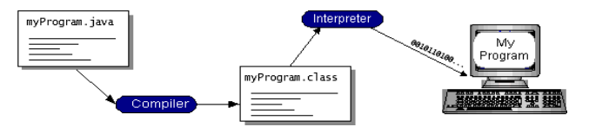

- JDK INSTALLATION:
For compiling and running java programs we need to install JDK.
A JDK distribution consists of a JRE distribution (a Java Virtual Machine implementation) plus a collection of development tools including javac: a Java compiler, and javadoc: Java documentation generator.

DOWNLOADING JDK 7:
Follow the steps for downloading jdk from net.
- Go to this link and download latest JDK (Java SE Development Kit 17).
http://www.oracle.com/technetwork/java/javase/downloads/index.html
- Click on the exe file and it will start downloading.
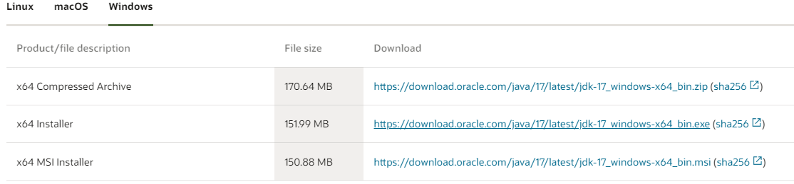
- After downloading, double click the jdk icon to start installation process.
INSTALLATION STEPS:
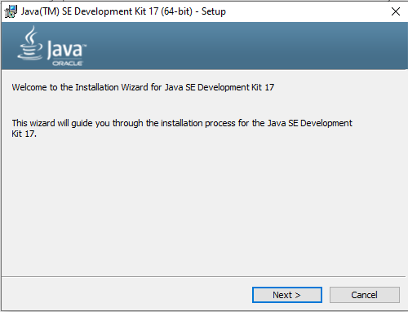
- Click NEXT to move ahead.
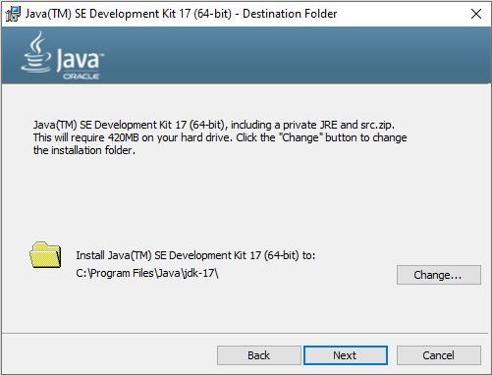
- Click NEXT
- Now JRE will start installing.
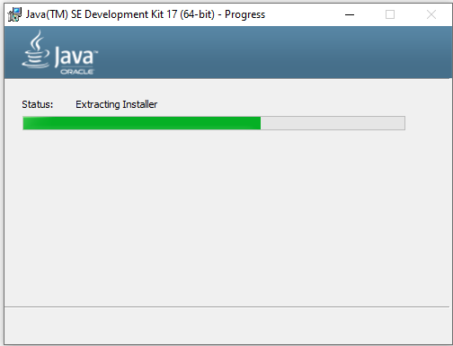
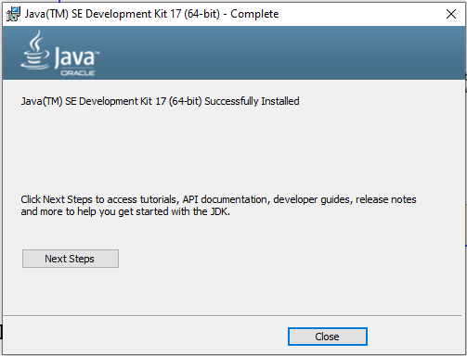
- Click close button to end installation process.
- Now you can create, compile and run java programs.
Note: For Lab, JDK will be provided to you to install in the system or you can directly download if internet is available.
2. CREATING A SIMPLE JAVA PROGRAM:
- Open up an editor (notepad) and write the following code.
class FirstProgram
{
public static void main(String abc[])
{
System.out.println("My first Java Program");
}
}

- Save the file as FirstProgram.java in our working folder C:\workspace (a folder created in C for lab tasks)
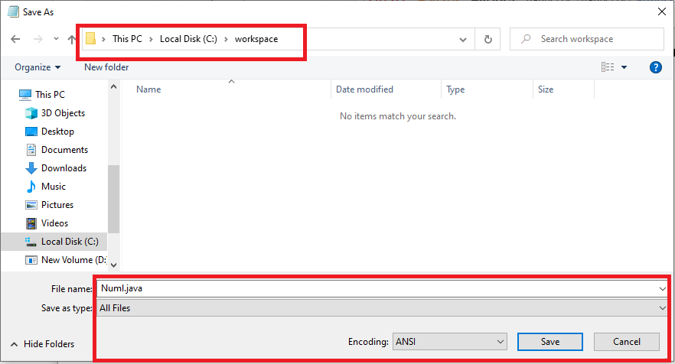
- In order to compile and run the program do the following: open the command prompt.
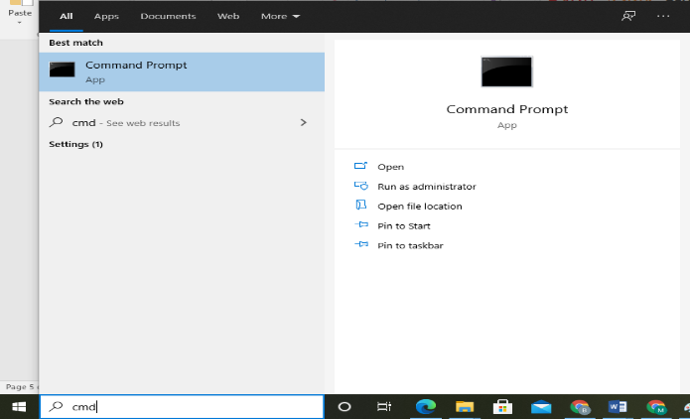

- Go to Directory C:\workspace. Compile the code of Java program using command:

javac FirstProgram.java
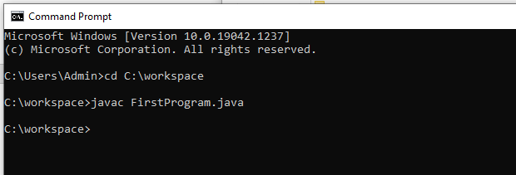
cd is used to change the directory. The command javac converts the java source code into byte code program.
- Assuming your program contains no errors, the compiler generates a byte code program that is equivalent of your source code. The compiler stores the byte code program in a file with the same name as source file, but with the extension “.class” that can be seen in the working directory.
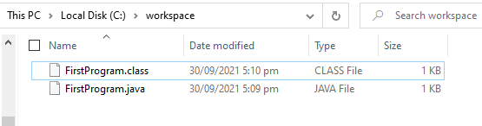

- You can also check it using “dir”.
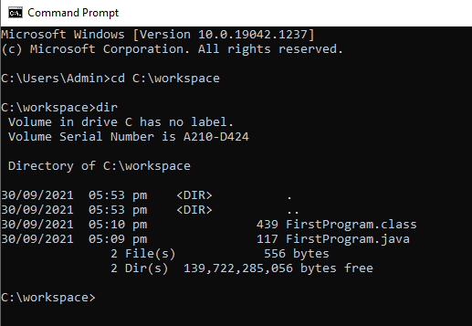
- To execute the byte code program in the .class file, enter the command java followed by the class name.
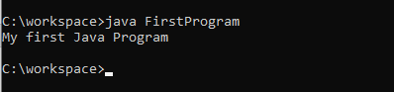

- If there is no exception in the program the output is printed on the command prompt.

LAB TASKS:
Task 1:
Write a code to print your name and roll number.
Task 2:
Can we save this code with some other name like Testing.java rather than with the class name? Try it.
class FirstProgram
{
public static void main(String abc[])
{
System.out.println("My first Java Program");
}
}
Task 3:
Run the following code and see the result.
Run the following programs. Observe the output. Focus on comments to enhance the understandability.
class Program2 {
public static void main(String args[]) {
int a,b,c; //this statement declares three variables a, b and c.
a=2;
b=3;
c=a+b;
System.out.println("Sum of two numbers = "+c); }
}
Task 4:
Run the following code by saving it firstly with name abc.java and then with bcd.java and check the output.
class abc
{
public static void main(String args[])
{
System.out.println(“hello world!”);
}
}
class bcd
{
public static void main(String args[])
{
System.out.println(“This is my First Program!”);
}}

